SECTION A [ 1mark]
- The correct cell to represent the following reaction is :
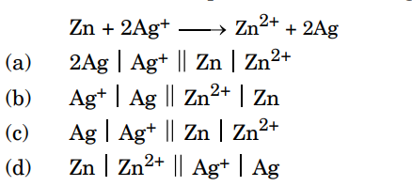

- 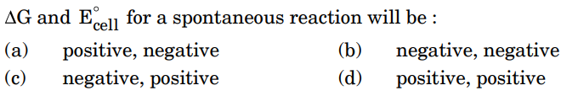
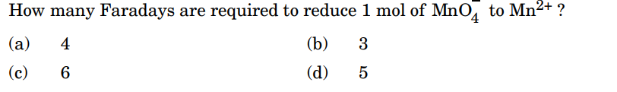
- Which of the following solutions of KCl will have the highest value of molar conductivity ? (a) 0.01 M
(b) 1 M
(c) 0.5 M
(d) 0.1 M
- Assertion (A): Conductivity decreases with decrease in concentration of electrolyte. 1 Reason (R): Number of ions per unit volume that carry the current in a solution decreases on dilution. (a) Both (A) and (R) are true and (R) is the correct explanation of (A).
(b) Both (A) and (R) are true, but (R) is not the correct explanation of (A).
(c) (A) is true, but (R) is false.
(d) (A) is false, but (R) is true.
- Assertion (A): Molar conductivity for weak electrolytes shows a sharp decrease when the electrolytic solution is diluted.
Reason (R) : For weak electrolytes, degree of dissociation increases with dilution of solution.

SECTION B [2 marks]

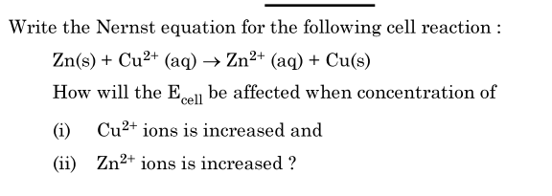
- In a plot of m against the square root of concentration (C1/2) for strong and weak electrolyte, the value of limiting molar conductivity of a weak electrolyte cannot be obtained graphically. Suggest a way to obtain this value. Also state the related law, if any.

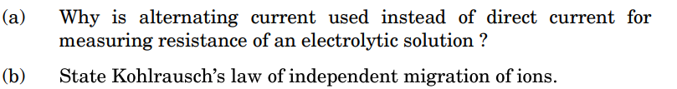

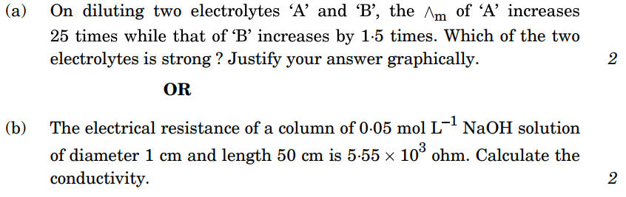

SECTION C [3 marks]

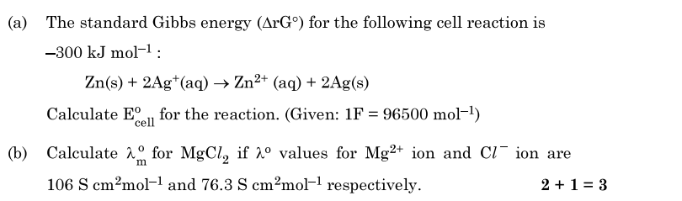
- The conductivity of 0·001 mol L 1 solution of acetic acid is 3·905 10 5 S cm 1 . Calculate its molar conductivity. If for acetic acid is 390·5 S cm2 mol 1 , then calculate its degree of dissociation ( ).

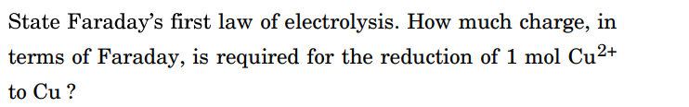.

- (a) Give reasons:
(i) Mercury cell delivers a constant potential during its life time.
(ii) In the experimental determination of electrolytic conductance, Direct Current (DC) is not used.
(b) Define fuel cell with an example. What advantages do the fuel cells have over primary and secondary batteries?

SECTION D [4 marks]
- Observe the figure and answer the following questions:
